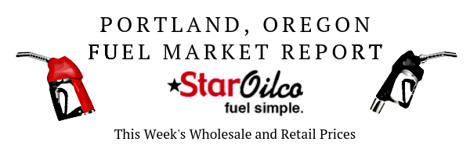
05/18/2020 Weeks Average

This Memorial Day weekend we saw gas prices lower than 2004, but not quite lower than 2003 like expected. The highest concentration of fuel prices being sold is on the west coast with Oregon and Washington following just behind California’s prices. Now according to gas buddy, the majority of prices being above $2.25 a gallon on in Oregon and Washington. As AAA Gas Prices show, we are on a steady incline into normal fuel prices. But what will be the new normal, lower or higher than what we were used to?

Rank Week Average
Wholesale Price Average | Wholesale Low | Wholesale Avg
E10 | 1.15 | 1.205
B5 | .9834 | 1.023

Retail Week Average
Retail Price Average | National | Oregon | Washington
E10 | 1.894 | 2.398 | 2.468
B5 | 2.412 | 2.561 | 2.668

Taxes
Taxes | Federal | State: OR | local | State: WA
Gas | .184 | .36 | .0-.13 | .494
Diesel | .244 | .36 | .0-.13 | .494

Follow Us:
Twitter: https://twitter.com/staroilco
Facebook: https://www.facebook.com/StarOilco/
Instagram: https://www.instagram.com/staroilcopnw/
Linkedin: https://www.linkedin.com/company/star-oilco/
Fuel News:
Lowest Gas Prices on Memorial Day Since 2003:
https://www.gasbuddy.com/go/memorial-day-gas-prices-2020/
Gas Prices Fluctuate Across the Country as More States Reopen:
https://csnews.com/gas-prices-fluctuate-across-country-more-states-reopen

